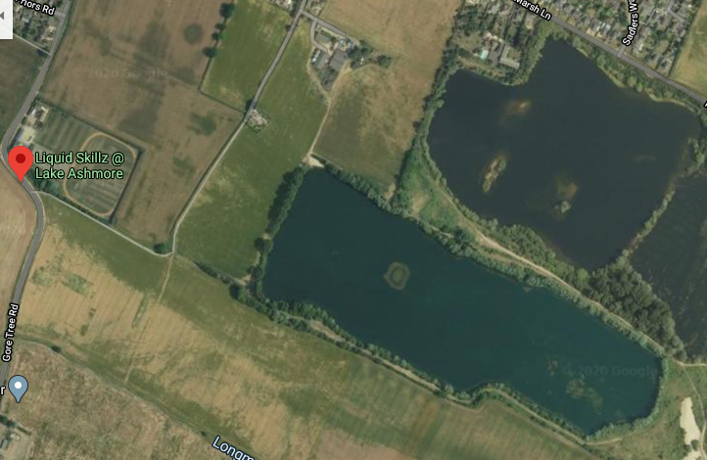
3
entrance
2
1
Car park
Club house

- Wakeboarding area.
- Swim meeting point and entry/exit.
- Island, lake is only 2 feet deep at island.
- Arrows mark main swim route
- Club house includes toilets, showers & light refreshment area.
- From car park follow the blue arrow to the swim meeting point.

